**1. Unity Version**

Android Version: 2020.3.9f1c1

IOS Version: 2019.4.40f1c1

**Note**: If you can't find the old version in Unity Hub, search for the corresponding version on the Unity official website and download it via Unity Hub.

Using the IOS Version as an Example：

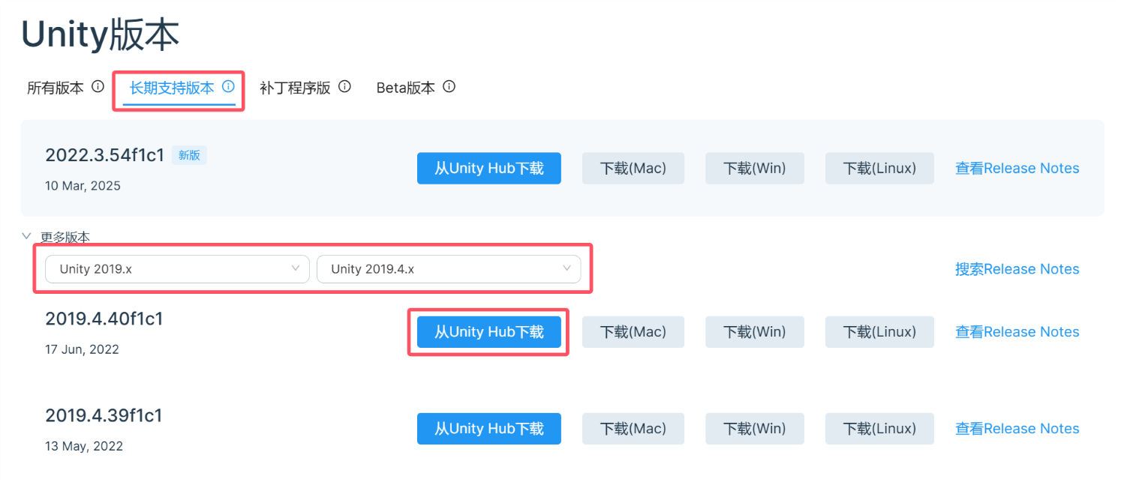

**2. Opening the Unity Project**

2.1、Using the Android Version as an Example.First, add the project to Unity Hub.

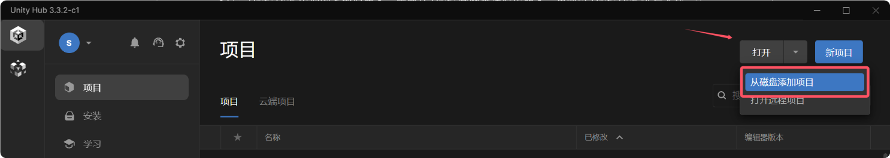

2.2、The path is the Assets folder.

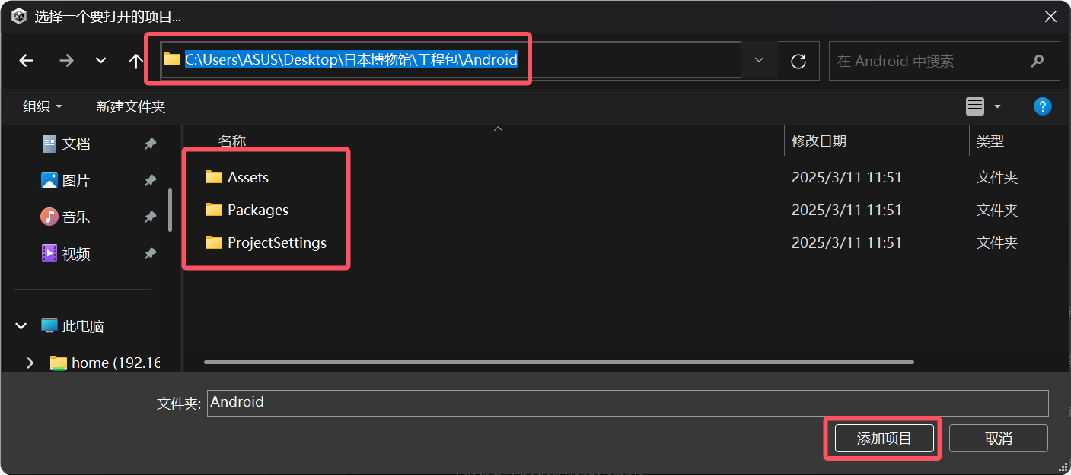

2.3、After adding the project, do not click on it directly, as Unity will default to reading Windows resources, which will take a long time. Instead, click on the version selection, choose the Android version, and then click the open button at the bottom right. This way, the project will read resources according to the Android version.

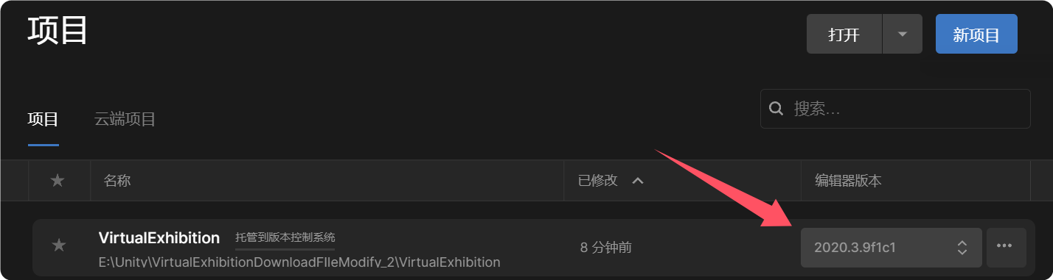

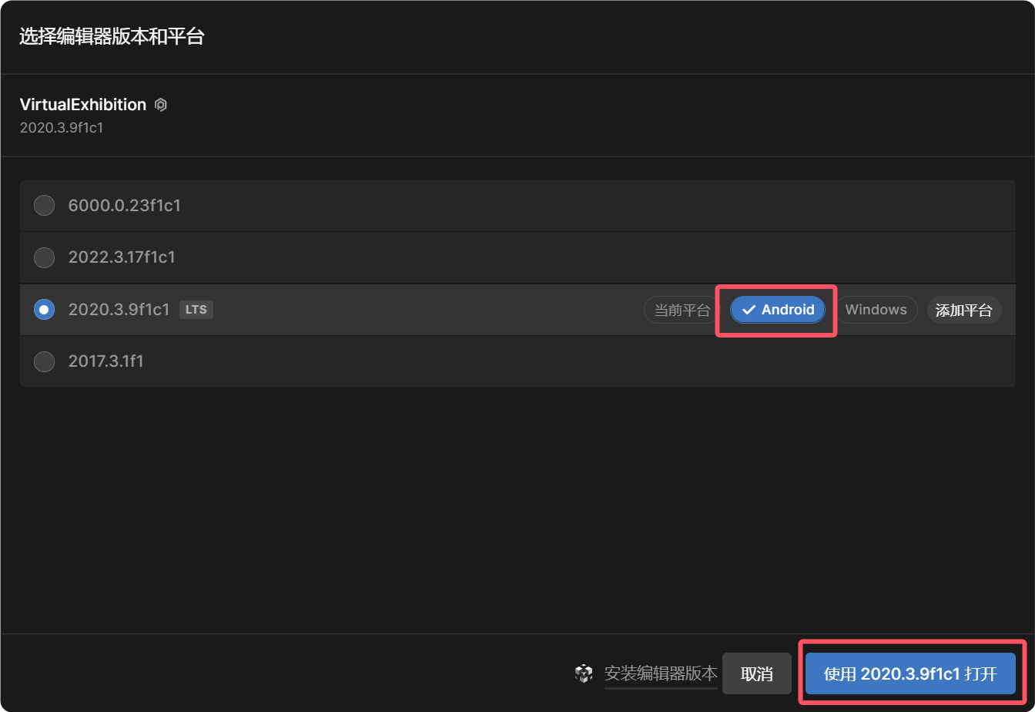

2.4、The method for opening the iOS version is the same; just select the iOS version.

**3. Main Folders of the Unity Project**

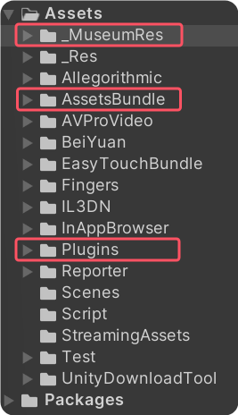

The three most important folders in the project are:

* _MuseumRes: Contains Unity scenes, 3D models, code scripts, UI, and fonts.
* AssetsBundle: Resource packages (AB packages) that need to be uploaded to the backend.
* Plugins: Files related to plugins for different platforms.

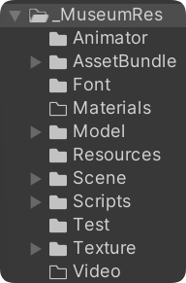

Detailed Introduction to the _MuseumRes Folder:

* _MuseumRes/AssetBundle: Scenes for each scene that need to be uploaded to the backend.
* _MuseumRes/Font: Fonts used in the project.
* _MuseumRes/Model: All 3D models.
* _MuseumRes/Resources: Dynamically loaded resources.
* _MuseumRes/Scene: Unity scenes.
* _MuseumRes/Scripts: Code scripts.
* _MuseumRes/Texture: UI and posters.

**4. Main Unity Scenes**

路径为：Assets\_MuseumRes\Scene\Akita&Settsu文件夹内

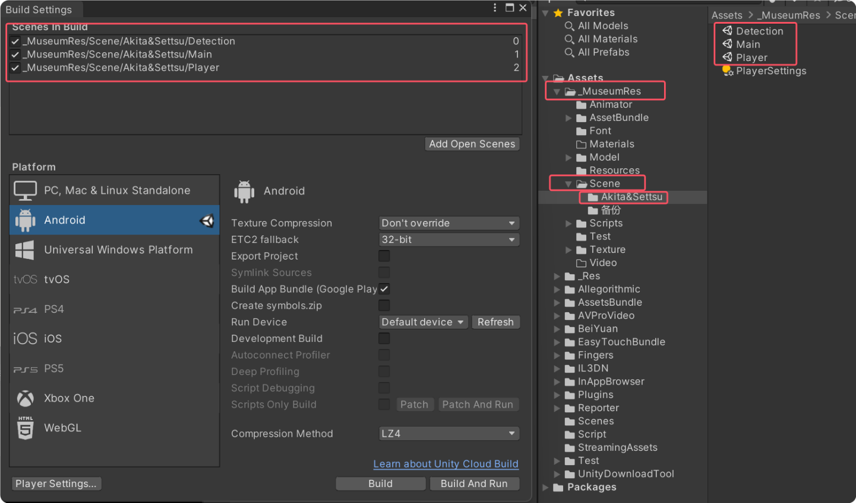

Unity场景Detection：检测App版本。

Unity场景Main：账号的登录注册以及3D场景资源和画作的检测与下载。

Unity场景Player：进入场景内的交互。

4.1、Unity Scene Detection:

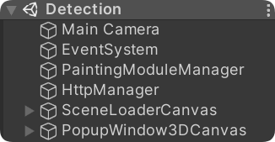

* PaintingModuleManager: Manages the painting module, checks the App ID and version.
* HttpManager: Manages network requests, retrieves data from the backend, and checks the current App ID and version.
* SceneLoaderCanvas: Progress bar module.
* PopupWindow3DCanvas: UI module. Manages UI logic and language switching. (Contains obsolete UI elements due to version iteration.)

4.2、Unity Scene Main:

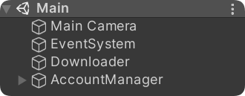

* Downloader: Manages network downloads, downloads backend resource packages.
* 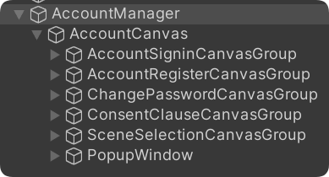AccountManager: Manages account and room UI, handles login interface UI and scene interaction.
* AccountSigninCanvasGroup: Account login interface UI.
* AccountRegisterCanvasGroup: Account registration interface UI.
* ChangePasswordCanvasGroup: Account password change interface UI.
* ConsentClauseCanvasGroup: Account consent clause interface UI.
* SceneSelectionCanvasGroup: Scene selection interface UI.
* PopupWindow: Popup prompt UI.

4.3、Unity Scene Player:

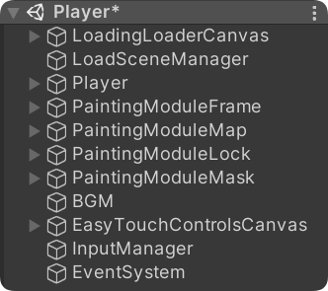

* LoadingLoaderCanvas: Loading UI display module.
* LoadSceneManager: Loads the resource package for the scene based on the entered scene.
* Player: The camera player that moves within the scene.
* PaintingModuleFrame: Manages frame animations, introductions, videos, audios, and their UI controls.
* PaintingModuleMap: Manages the minimap and its settings and UI controls.
* PaintingModuleLock: Locks the account when a visitor accesses a painting and reminds the user to register.
* PaintingModuleMask: Blocks UI clicks outside popups to prevent accidental touches.
* BGM: Controls background music within the scene.
* EasyTouchControlsCanvas and InputManager: Joystick control module.

**Note**: The EventSystem in Unity scenes is Unity's built-in UI event script.